

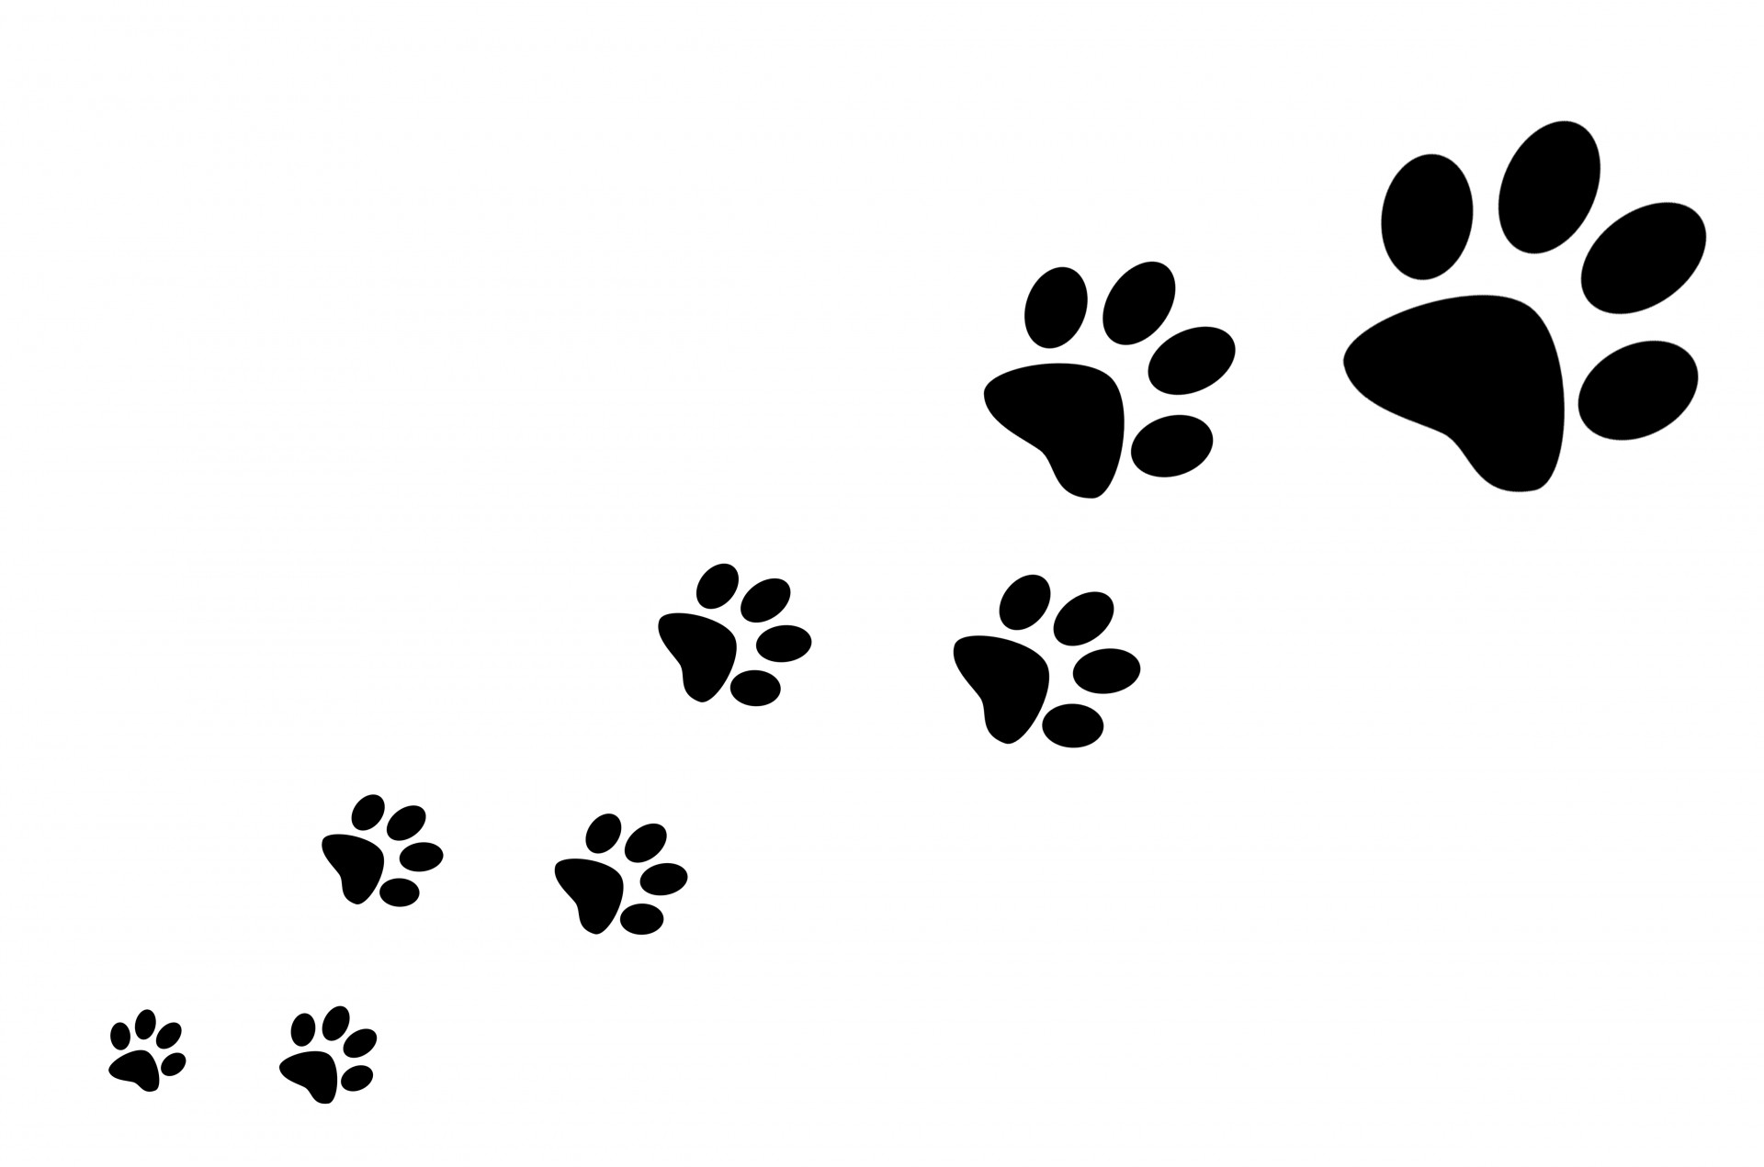

Saluda’s 57th annual Coon Dog Day Festival is Saturday, July 11, 2020. As you may know, Coon Dog Day began as a benefit chicken supper fundraiser for the local coon club in 1963. Hopefully, again this year thousands of people will enjoy the 5K Race, the mid-day parade, free music, as well as great food and homemade crafts from the Coon Dog Day Vendors and from the local shops and restaurants.

The Festival is free to the public, and their dogs are welcome as long as they are leashed.

This year any monies remaining after all expenses have been paid will be used to help build public restrooms in Pace Park in downtown Saluda.

If you would like to offer your monetary support of the 57th Annual Coon Dog Day Festival, please complete the Sponsorship Registration Form, attach your check made payable to the City of Saluda designated for Coon Dog Day Sponsorship, and mail them to City of Saluda; P. O. Box 248; Saluda NC 28773. Or please take your donation to City Hall at 6 East Main Street.

Of course, we will also gladly accept any amount donated to the Festival!

Sponsorship opportunities will be open until June 8, 2020, to give us time to print the 5K Race t-shirts with the Sponsors’ logos and information on them.

We hope you will consider a Sponsorship of the Festival and that you enjoy some of what makes Saluda such a unique place to work and live.

If you want to participate in the BIG parade, just get in line! Find all of the Coon Dog Day information on the website, cityofsaludanc.com.



SALUDA’S COON DOG DAY

P. O. BOX 248

SALUDA NC 28773



**GOLD SPONSOR**

**$ 500**

* Opportunity to provide your Company banner to be hung on the main stage during the Festival
* Direct link from City/Festival websites to your Company website
* Your large Company logo on 5K Race T-shirts
* Recognition through announcements from the main stage downtown during the Festival
* Opportunity to include promotional items/samples/coupons in 5K Race Cinch Sacks

**SILVER SPONSOR**

**$ 250**



* Direct link from City/Festival websites to your Company website
* Your Company logo on 5K Race T-shirts
* Recognition through announcements from the main stage downtown during the Festival
* Opportunity to include promotional items/samples/coupons in 5K Race Cinch Sacks

**SALUDA’S 57th ANNUAL COON DOG DAY FESTIVAL**

**July 11, 2020**

**Sponsorship Registration Form**

Please complete the information below and return with your check for the desired Sponsorship Level before June 8, 2020. Please list the name of your Company as you would like it to appear in the promotional materials for the Event.

Sponsor Level (check one):

_____ Gold ($500)

_____ Silver ($250)

Company Name (exactly as you would like it to appear on all materials):

___________________________________________________________________________________________________

Contact Person’s Name: ___________________________________________________________________________

Mailing Address: __________________________________________________________________________________

Physical Address: _________________________________________________________________________________

Phone: _____________________________________ Fax: ________________________________________________

Email Address: ___________________________________________________________________________________

*We will provide _____# of items for the Coon Dog Day 5K Race Cinch Sacks (all items to be included must be delivered to Saluda City Hall; 6 East Main Street; prior to July 3, 2019). We expect 200+ participants.

The type of item(s) you would like to provide could include gift certificates or coupons, key chains, or other promotionally printed items.

I understand that I must provide payment in full, along with this Sponsorship Registration Form and a high resolution logo in digital format in order to participate fully in all promotional opportunities described above.

Printed Name: ____________________________________ Signature: ______________________________________

**ANY DONATION WILL BE GREATLY APPRECIATED!**

Please make checks payable to City of Saluda, for Coon Dog Day Sponsorship/Donation and return to:

City of Saluda

P. O. Box 248

Saluda NC 28773

Fax: 828 749-2373